**SOFTWARE ENGINEERING -CSA1008**

**Name: Y.Harsha Vardhan Reddy**

**Reg.no: 192011494L**

**1Q. Draw a USE-CASE diagram for Online Voting System using CASE tools**

***Aim:*** To draw a use case diagram for online voting system using case tools.

***Software Used:*** Umbrello.

***Diagram:***

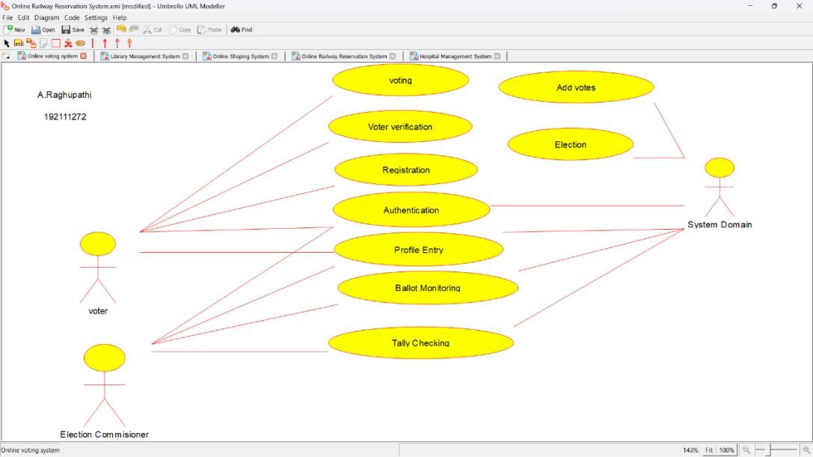

Rajesh

**Result:** Drawing a use case diagram for online voting system was completed successfully.

**2Q. Draw a USE-CASE diagram for Library Management System using CASE tools.**

**Aim:** To draw a use case diagram for library management system using case tools.

**Software Used:** Umbrello.

**Diagram:**

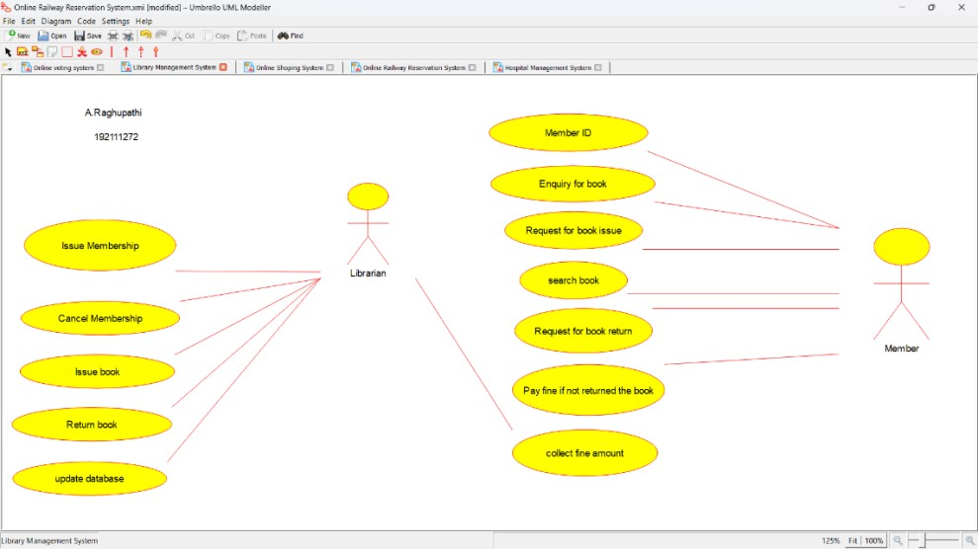

Rajesh

**Result:** Drawing a use case diagram for library management system was completed successfully.

**Q. Draw and validate the flowchart to compute the quotient and remainder.**

**3**

**Aim:**

To draw and validate the flowchart to compute the quotient and remainder.

**Software Used:**

Raptor.

**Diagram:**

**Result:**

Flowchart to compute the quotient and remainder was completed and output verified.

**4**

**Q**

**. Draw a USE**

**-**

**CASE diagram for Online Shopping system using CASE tools.**

**Aim:**

To draw a use case diagram for online shopping system.

**Software Used:**

Umbrello.

**Diagram:**

**Result :**

Drawing of use case diagram for online shopping voting

system was successfully completed.

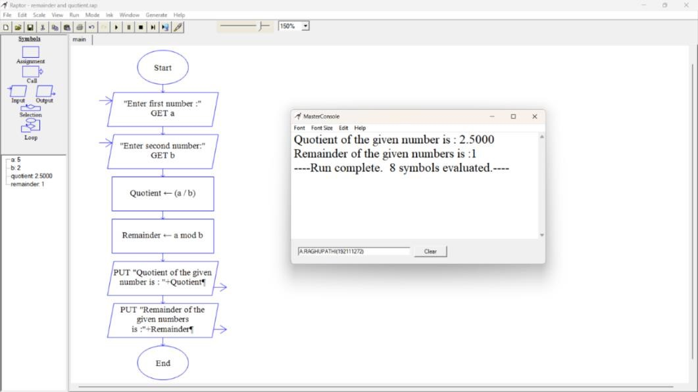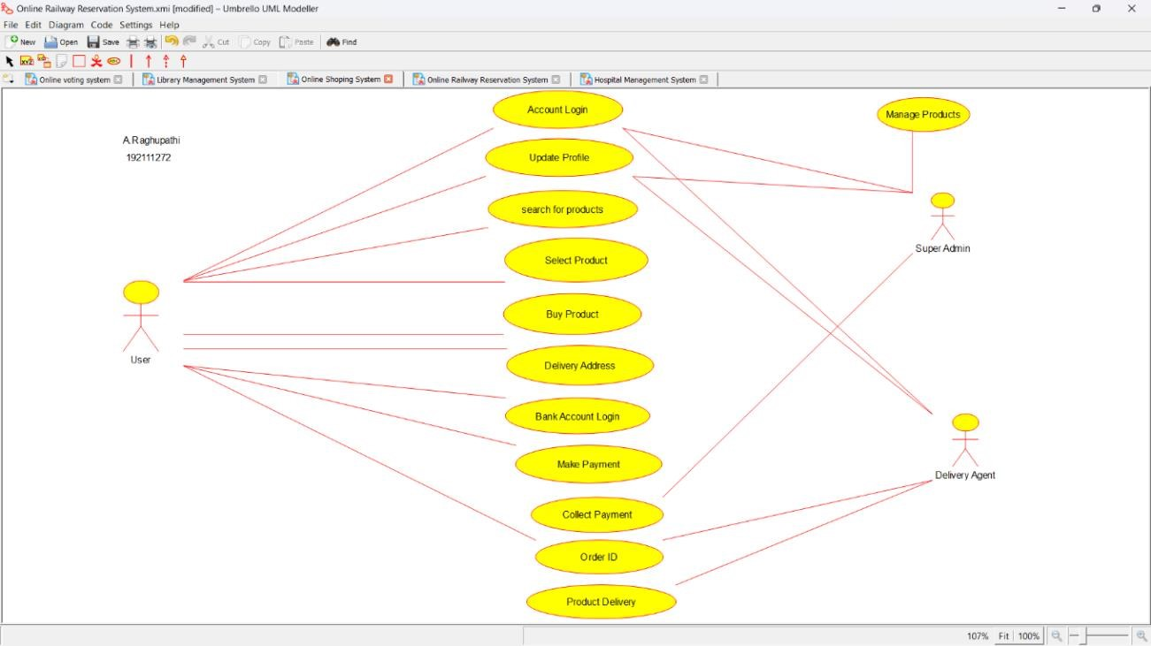

Rajesh



**5Q. Draw a USE CASE diagram for Online Railway Reservation System using CASE tools.**

**Aim:** To draw a use case diagram for online railway reservation system.

**Software Used:** Umbrello.

**Diagram:**

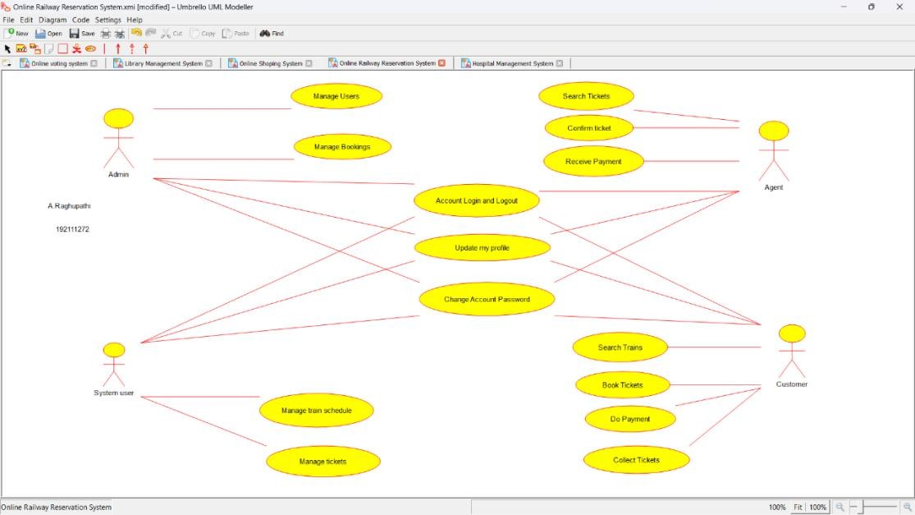

Rajesh

**Result :** Use case diagram for online railway reservation system was successfully completed.

**6Q. Draw a USE-CASE diagram for Hospital Management System using CASE tools.**

**Aim:** To draw a use case diagram for hospital management system.

**Software Used:** Umbrello.

**Diagram:**

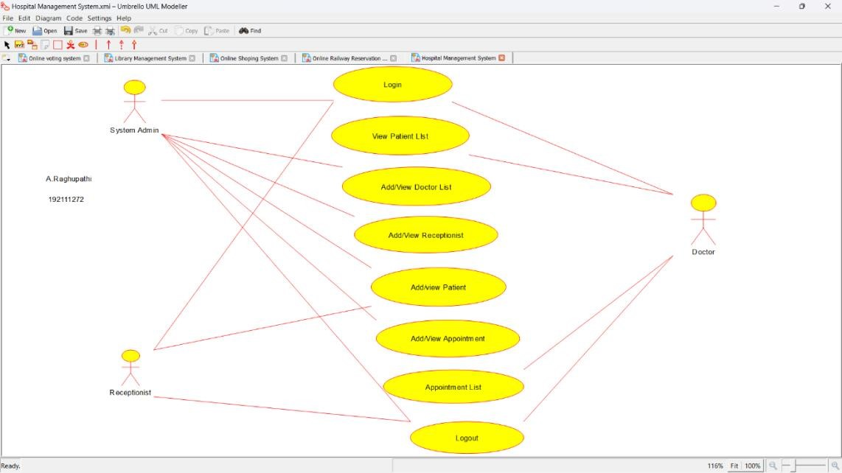

Rajesh

**Result :** Use case diagram for hospital management system was successfully completed.

**7Q. Draw a USE CASE diagram for ATM System using CASE tools.**

**Aim:** To draw a use case diagram for ATM system.

**Software Used:** Umbrello.

**Diagram:**

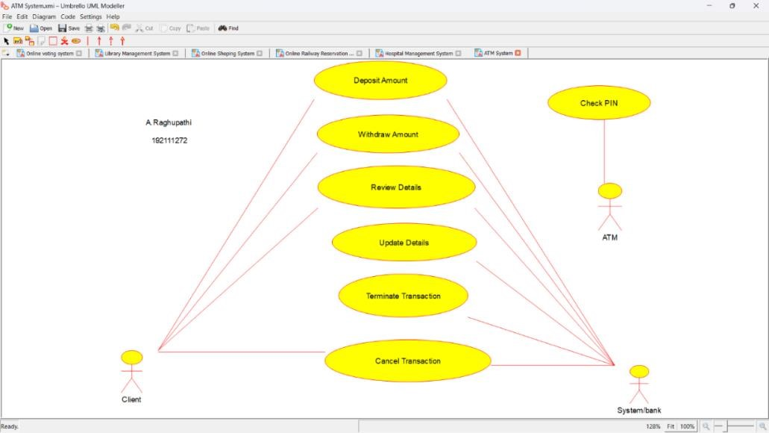

Rajesh

**Result :** Use case diagram for ATM system was completed successfully.

**8Q. Draw a USE-CASE diagram for Online college management System using CASE tools.**

**Aim:** To draw a use case diagram for online college management system.

**Software Used:** Umbrello.

**Diagram:**

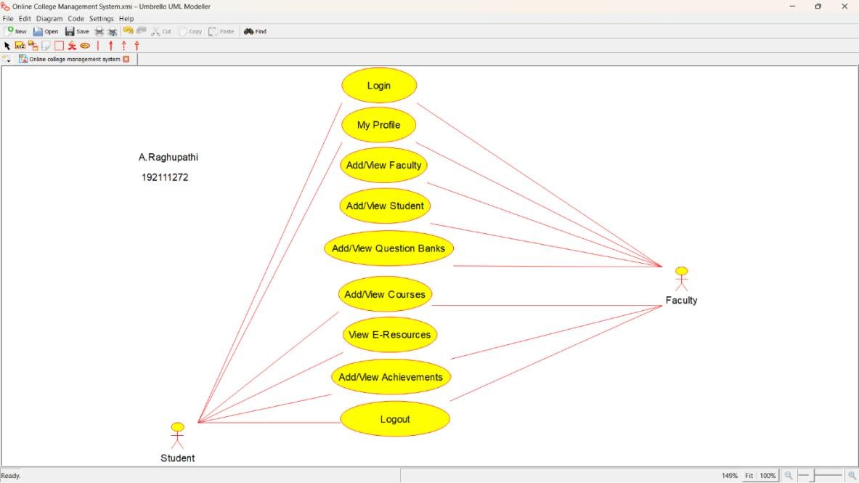

Rajesh

**Result :** Use case diagram for online college management system was successfully completed. **9Q. Draw a USE CASE diagram for Online Airline Reservation System using CASE tools.**

**Aim:** To draw a use case diagram for online airline reservation system. **Software Used:** Umbrello **Diagram:**

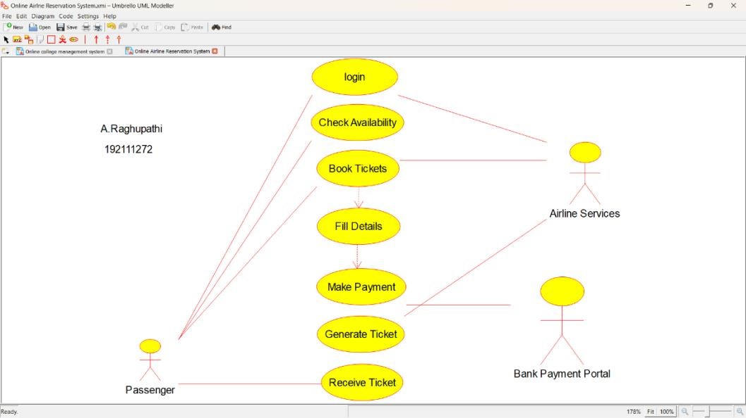

Rajesh

**Result:** Use case diagram for online airline reservation system was successfully completed.

**10Q. Draw a Class diagram for Online Airline Reservation System using CASE tools.**

**Aim:** To draw a class diagram for online airline reservation system.

**Software Used:** Umbrello.

**Diagram:**

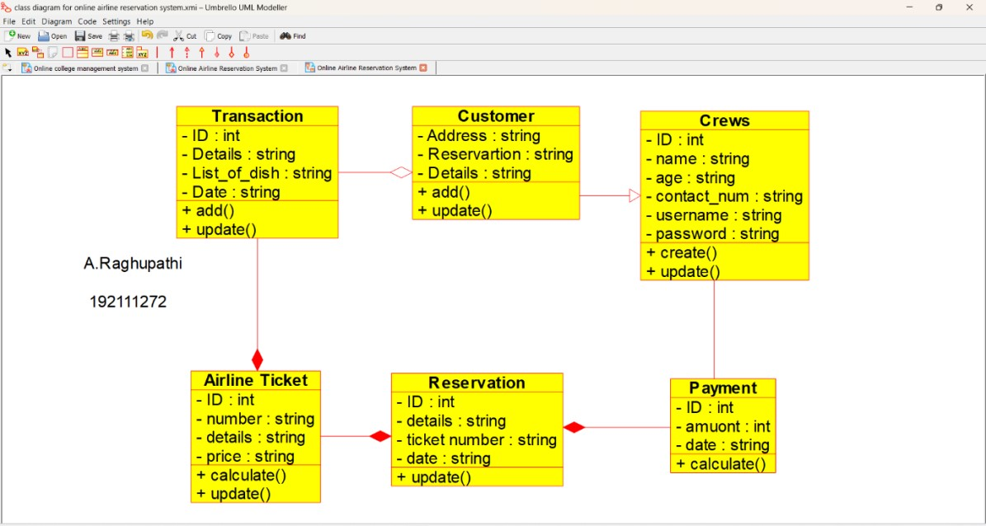

Rajesh

**Result:** Class diagram for online airline reservation system was successfully completed.

**11Q. Draw a Class diagram for Online Voting System using CASE tools**

**Aim:** To draw a class diagram for online voting system.

**Software Used:** Umbrello.

**Diagram:**

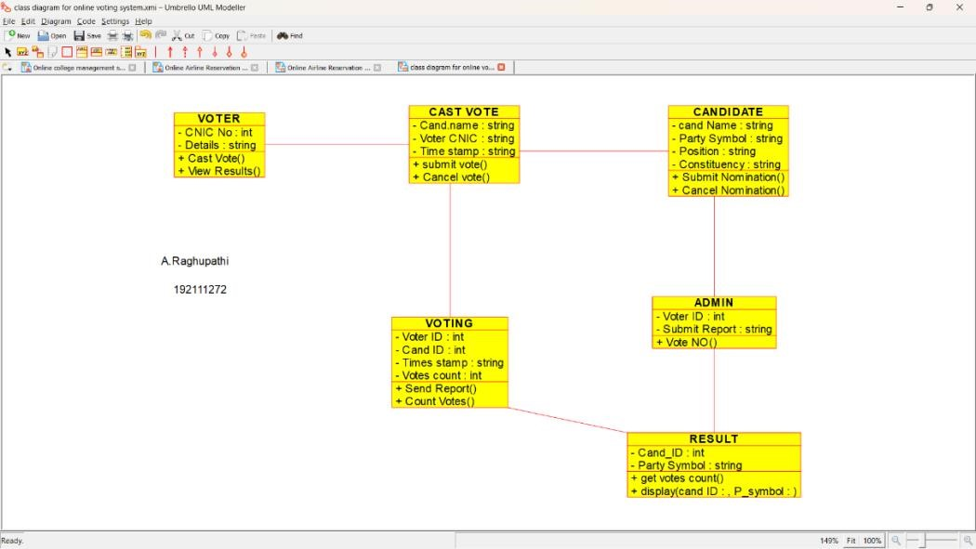

Rajesh

**Result:** Class diagram for online voting system was successfully completed.

**12Q. Draw a Class diagram for Library Management System using CASE tools.**

**Aim:** To draw a class diagram for library management system.

**Software Used:** Umbrello.

**Diagram:**

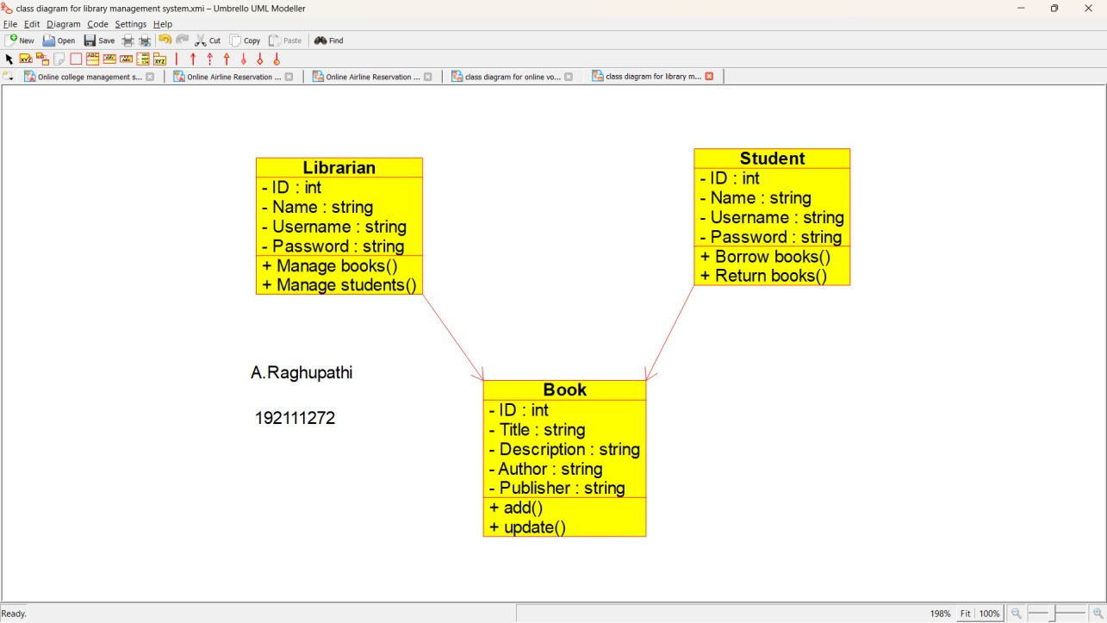

**Result:** Class diagram for library management system was successfully completed.

**13. Draw a Class diagram for Online Shopping system using CASE tools.**

**Aim:** To draw a class diagram for online shopping system using case tools.

**Software used:** Umbrello.

**Diagram:**

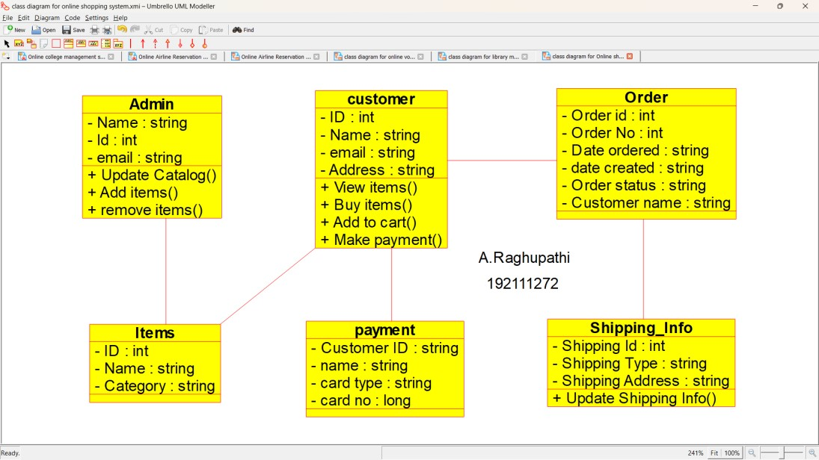

**Result:** Class diagram for online shopping system was completed successfully.

**14Q. Draw a Class diagram for Online Railway Reservation System using CASE tools.**

**Aim:** To draw a class diagram for online railway reservation system.

**Software used:** Umbrello.

**Diagram:**

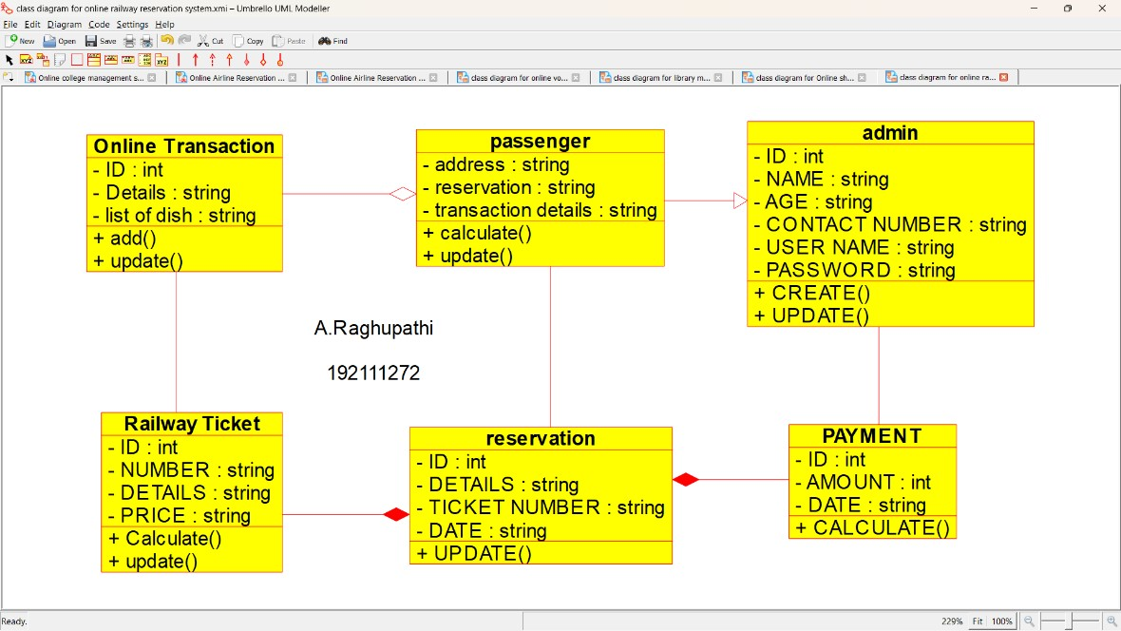

**Result:** Class diagram for online railway reservation system was successfully completed.

**15Q. Draw a Activity diagram for Online Voting System using CASE tools.**

**Aim:** To draw a activity diagram for online voting system.

**Software used:** Umbrello.

**Diagram:**

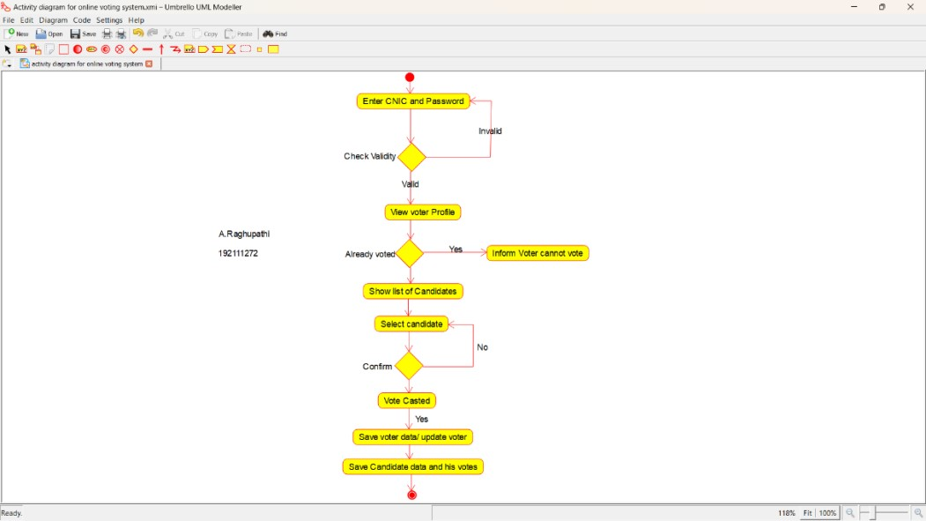

**Result:** Activity diagram for online voting system was successfully completed.

**16Q. Draw a Activity diagram for Library Management System using CASE tools.**

**Aim:** To draw a activity diagram for library management system **Software used:** Umbrello.

**Diagram:**

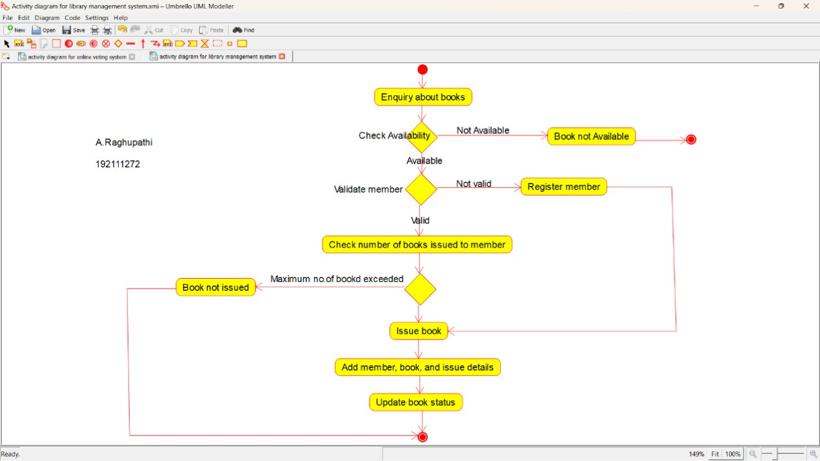

**Result:** Activity diagram for library management system was successfully completed.

**17Q. Draw a Activity diagram for Online Shopping system using CASE tools.**

**Aim:** To draw a activity diagram for online shopping system.

**Software used:** Umbrello.

**Diagram:**

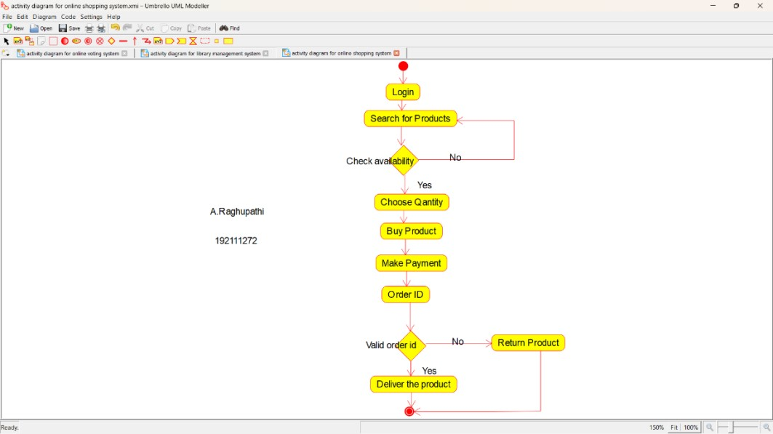

**Result:** Activity diagram for online shopping system was successfully completed.

**18Q. Draw a Activity diagram for Online Railway Reservation System using CASE tools.**

**Aim:** To draw a activity diagram for online railway reservation system.

**Software used:** Umbrello.

**Diagram:**

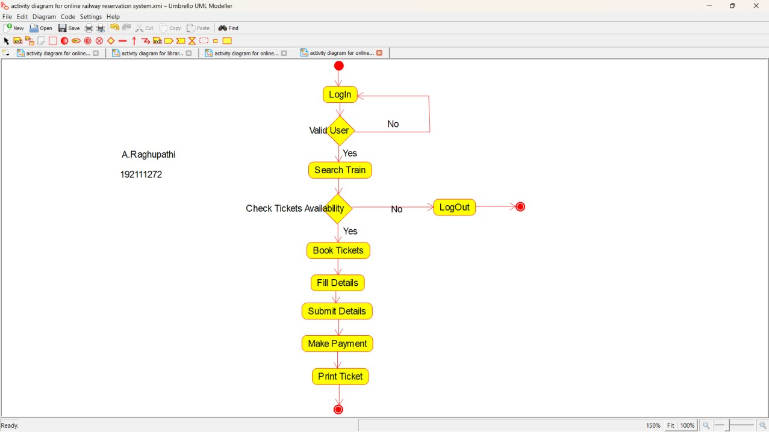

**Result:** Activity diagram for online railway reservation system was successfully completed.

**19**

**Q**

**. Draw a Activity diagram for Hospital Management System using CASE tools.**

**Aim:**

To draw a activity diagram for

hospital management system.

**Software used:**

Umbrello

.

**Diagram:**

**Result:**

Activity diagram for hospital management system was successfully completed.

**20**

**Q**

**. Using Raptor**

**-**

**Draw the flowchart to check whether the given number is a palindrome or not.**

**Aim**

**:**

To draw the flowchart to check whether the

given number is a palindrome or not.

**S**

**o**

**ftware used:**

Raptor.

**Diagram:**

**Result:**

Flowchart

to

check whether the given number is palindrome or not was completed and output verified.

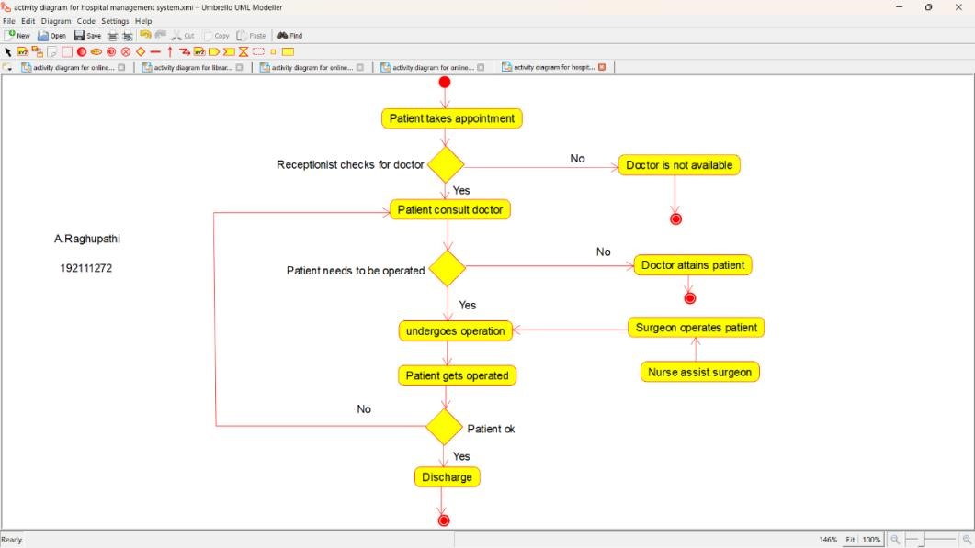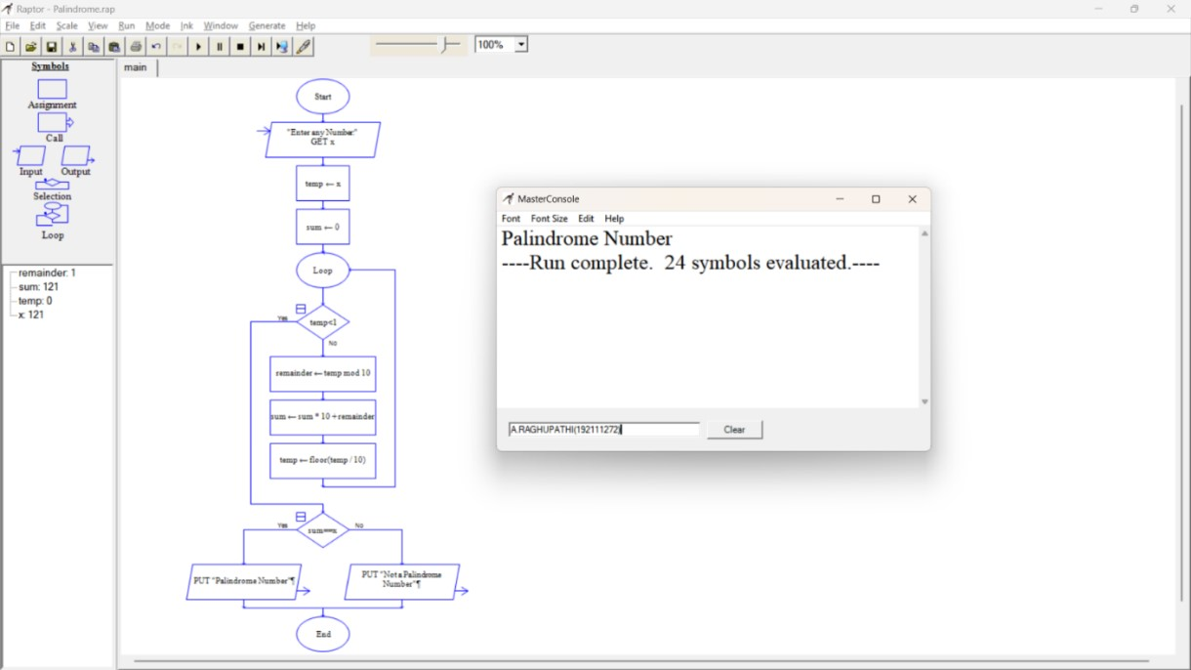

**21**

**Q**

**. Using Raptor**

**-**

**Draw and validate the flowchart to calculate Fibonacci series.**

**Aim:**

To draw and validate the flowchart to calculate Fibonacci series.

**Software used:**

Raptor.

**Diagram:**

**Result:**

Flowchart to calculate Fibonacci series was completed and output verified.

**22**

**Q**

**. Using Raptor**

**-**

**Draw and validate the flowchart to swap two characters.**

**Aim:**

To draw

and validate the flowchart to swap two characters.

**Software used:**

Raptor.

**Diagram:**

**Result:**

Flowchart to swap two characters was completed and output

verified.

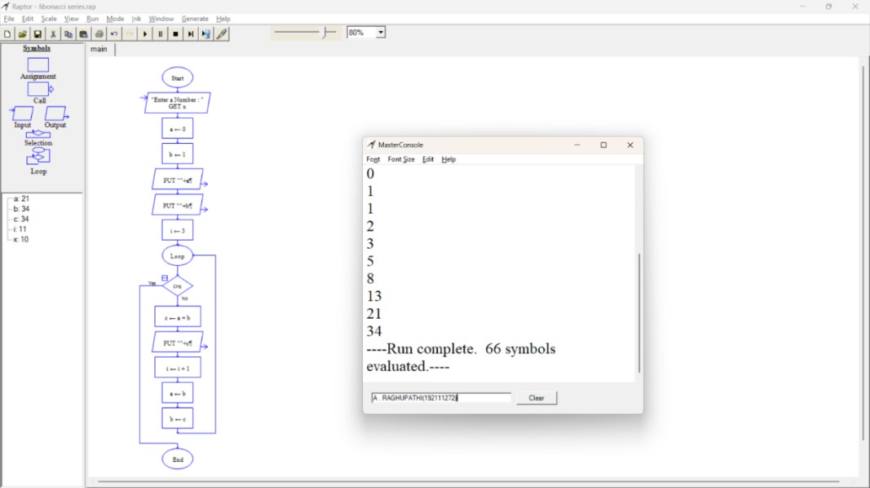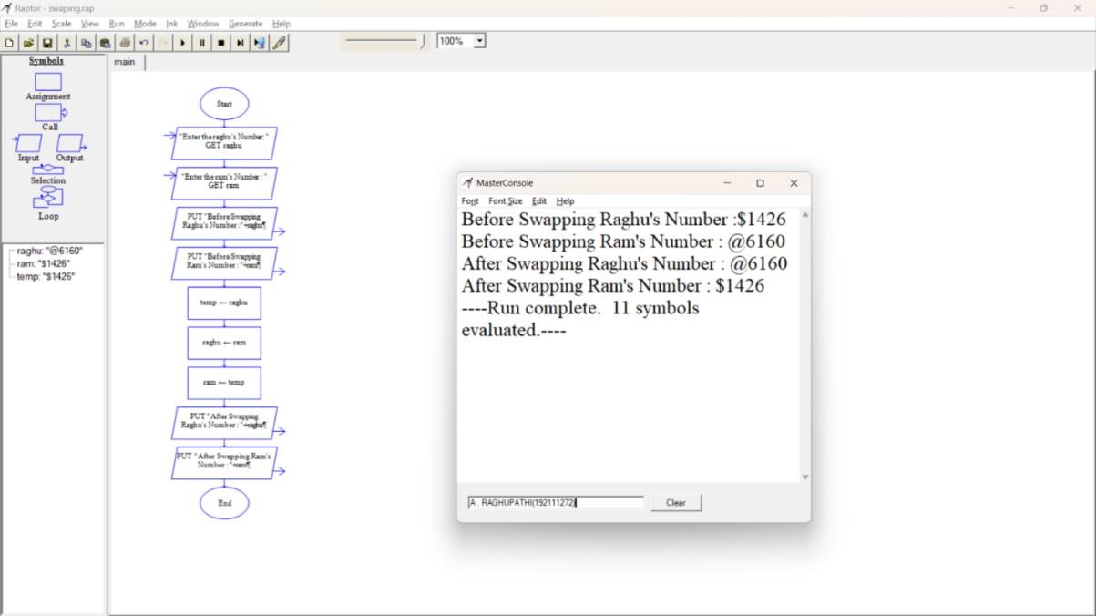

**23**

**Q**

**. Using Raptor**

**-**

**Draw the flowchart to display the length of the string.**

**Aim:**

To draw the flowchart to display the length of the string.

**Software used:**

Raptor.

**Diagram:**

**Result:**

Flowchart to display the length of the string was

completed and output verified.

**24**

**Q**

**. Using Raptor**

**-**

**Draw the flowchart to find whether the given number is prime or not.**

**Aim:**

To draw the flowchart to find whether the given number is prime or not.

**Software used:**

Raptor.

**Diagram:**

**Result:**

Flowchart to find whether the given number is prime or not was completed and output verified.

